# MODUL 5 Describing Things and Places

|  |  |
| --- | --- |
|  | CAPAIAN PEMBELAJARAN |
| Siswa mampu mendeskripsikan benda dan tempat menggunakan Bahasa Inggris yang baik dan benar. | |

|  |  |
| --- | --- |
|  | KEBUTUHAN ALAT/BAHAN/SOFTWARE |
| * Handphone * Laptop | |

|  |  |
| --- | --- |
|  | DASAR TEORI |

Describing things:

Untuk mendeskripsikan benda, struktur kalimat yang digunakan adalah kalimat nominal:

**S + tobe: is/am/are + ANA**

Contoh kalimat:

*The floor is slippery.*

*The children are smart.*

*The girl is beautiful.*

Atau **verbal linking** seperti

**S + Verb: have/seem/appear/sound/smell/feel etc + O/C**

Contoh kalimat:

*The book seems thick.*

*The car has blue wheels.*

*The young man seems good looking.*

Bentuk yang lain adalah bentuk frasa adjective.

Rumusnya:

**ADJ + NOUN**

**ADJ: Qua Si A Te Pa Sha C O M**

Berikut adalah penjelasannya : QuaSiATePaShaCOM

|  |  |  |  |  |  |  |  |  |  |
| --- | --- | --- | --- | --- | --- | --- | --- | --- | --- |
| Qua | Si | A | Te | Pa | Sha | C | O | M | Noun |
| Quality | Size | Age | Temperature | Participle | Shape | Colour | Origin | Material | Benda |
| Kualitas:  Handsome, expensive, cheap, amazing, wonderful | Ukuran:  Big, small, medium, huge, tall, short | Usia:  Old, young, ancient, novel | Suhu:  Hot, cold, warm, humid, scorching, | **V3:** (yang di)  Interested, excited,  **Ving:**  Interesting, peasing, exciting | Bentuk:  Oval, square, round, | Warna:  Blue, red, yellow, purple | Asal:  American, Javanese, German, Dutch | Bahan:  Wooden, metal, silver, plastic, | Bendanya:  Book, car, chair, man, woman, etc |

Example:

|  |  |
| --- | --- |
| **Benda**: Perfume  **Adjective**: luxurious, gold, American, interesting, | It is a *luxurious interesting gold American* **perfume**. |
| **Benda:** luggage  **Adjective:** old, red, cheap, big, plastic, Italian | I have a *cheap big old red plastic Italian* **bag**. |
| **Benda**: car  **Adjective**: expensive, maroon, small, German | My brother has an *expensive small maroon German* **car** in his garage. |

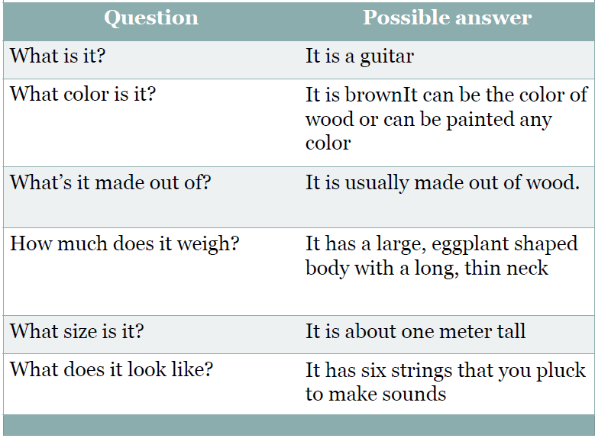To describe things, you need to pay attention to these following:

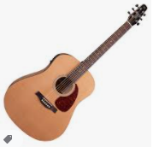

**DESCRIBING PLACES**

Perhatikan table di bawah:

|  |  |  |
| --- | --- | --- |
| Kosa kata yang digunakan | Menanyakan arah | Meberikan arah |
| * Near (Dekat) * Behind (Di belakang) * Beside (Di samping) * Next to (Di samping) * Turn Right (Belok ke kanan) * Turn Left (Belok ke kiri) * In front of (Di depan) * Go straight (Jalan lurus) * Between (Di antara 2 benda) * Among (Di antara lebih dari 2 benda) * Across (Di seberang) * Go past (Melewati) * Opposite (Berlawanan) * Intersection (Perempatan) * T-Junction (Pertigaan) * On the corner of (Di pojok) | * *Excuse me,* ***could you show me the way to the*** *nearest Cinema?* (Permisi, apakah kamu bisa menunjukkan jalan ke bioskop terdekat?) * ***Where is the Nara Park****?* (Ada di mana Taman Nara?) * ***Can you tell me how to get*** *to train station from here?* (Bisakah kamu menunjukkan cara ke stasiun kereta dari sini?) * ***I am trying to find a Mitra Hospital. Could you tell me how to get*** *there?* (Aku sedang mencari Rumah Sakit Mitra. Bisakah kamu memberitahuku cara ke sana?) * ***Is this the right way*** *for the mall?* (Apakah ini jalan yang benar untuk menuju ke mall?) * ***Is there a mosque*** *around here?* (Apakah ada masjid di sekitar sini?) | * ***Go straight*** *along this road and you’ll find the bank next to Mangia restaurant.* (Jalan lurus sepanjang jalan ini dan kamu akan melihat bank di samping restoran Mangia) * ***Just turn the right*** *and you’ll find the mosque. It’s* ***near*** *the park*. (Belok ke kanan dan kamu akan melihat masjid. Lokasi masjid dekat dengan taman) * ***You’re going in the wrong direction****.* (Kamu berada di jalan yang salah) * ***Go straight*** *until you pass a bakery on your left.* (Jalan lurus sampai kamu menemukan toko roti di sebelah kiri) * ***Turn left*** *at the intersection and it is across the post office.* (Belok ke kiri di perempatan dan tempatnya di seberang kantor pos) |

**Pay attention to the picture**

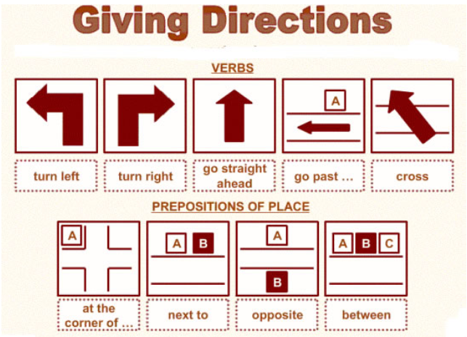

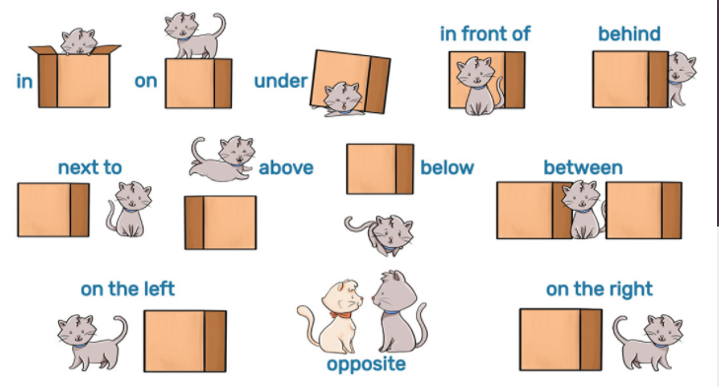

**Untuk mendiskripsikan tempat bisa menggunakan:**

**The book is *on* *the left side* of the bag. (S + tobe + prep of place + noun)**

**The man stands *beside* the woman. ( S + verb + prep of place + noun)**

|  |  |
| --- | --- |
|  | **LATIHAN** |

* Please open : [joinmyquiz.com](https://quizizz.com/join?gc=17702438#_blank)
* or open link:

<https://quizizz.com/join?gc=30376990>

* And enter this code **3037 6990**
* **Deadline: sesuai ELA**

|  |  |
| --- | --- |
| **tugas.png** | **TUGAS** |

Describe a place or tourist destination with the following directions:

**1. Introduction (Pengenalan)**

* informasi singkat mengenai nama dan letak dari lokasi
* alasan kenapa penulis memilih tempat itu untuk di ceritakan,
* Ex: apa yang membuat tempat itu terkenal, special dll

**2. Main Body (Inti)**

* memaparkan mengenai tempat/bangunan yang diceritakan.
* menceritakan dari bagian umum ke khusus
* mulai dari keseluruhan ciri dari tempat tersebut
* ex: pemandangannya, bangunannya, Cuacanya, dan lain lain, kemudian merujuk ke detail yang khusus yang melengkapi penjelasan umum sebelumnya.

**3. Conclusion (Kesimpulan)**

* kesimpulan setelah mengunjungi tempat tersebut.
* menggambarkan perasaan penulis, atau opini dari tempat tersebut,
* memberikan rekomendasi bagi para pembaca.

Perhatikan contoh berikut:

**Pink Beach**

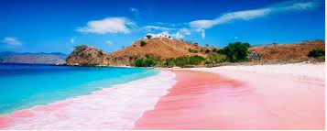  
Pink Beach or Pantai Merah Muda is one of the beaches in Komodo island, East Nusa Tenggara. The beach is called Pink Beach because the sand beach is pink. The pink color of its beach is a mixture of white sand beach colors mixed with crushed coral, shells, calcium carbonate from marine invertebrates that are very small, and also Foraminifera, microscopic amoeba that has a red body shell.  
          At Pink Beach, there are so many marine organisms. No fewer than 1,000 species of fish, 260 species of coral, and 70 species of sponge can be found here. Having so much marine life, this place is a proper spot for snorkeling and diving for sea sports lovers.

Source: <https://www.jagoanbahasainggris.com/2017/11/contoh-descriptive-text-tentang-tempat-wisata.html>

**Post the description to the following padlet link:**

[**https://padlet.com/kuliahnafisa/vgbes5hxl7u67g1r**](https://padlet.com/kuliahnafisa/vgbes5hxl7u67g1r)

|  |  |
| --- | --- |
|  | **REFERENSI** |

* 1. **Link youtube video describing things:** [**https://www.youtube.com/watch?v=Bv8MsuUKuJ8**](https://www.youtube.com/watch?v=Bv8MsuUKuJ8)
  2. **Link youtube giving direction :** [**https://www.youtube.com/watch?v=NGlK5nQgrxA**](https://www.youtube.com/watch?v=NGlK5nQgrxA)
  3. **Link youtube describing place :** [**https://www.youtube.com/watch?v=weAHqLJrPGU**](https://www.youtube.com/watch?v=weAHqLJrPGU)